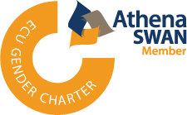
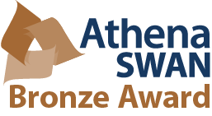

Equality and Diversity
Annual Report 2015/16
All Different: All Bournemouth University

@EqualityatBU
Equality and Diversity at BU
equalityatBU
EqualityatBU
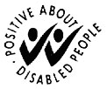
www.bournemouth.ac.uk/diversity
Table of Contents

1. Foreword 3

2. Equality and diversity at BU: headlines for 2015/16 4
2.1 Policy 4
2.2 Students and staff 4
2.3 Community 5
3. Equality and diversity work for 2016/17 will include: 6

4. Impact 7
Impact 1: Dignity and Respect 7
Impact 2: Gender Equality 8
Impact 3: Mental Health 9
Impact 4: Students’ Union (SUBU) Equality and Diversity events 10

5. Equality data 11
5.1 HESA student equality data 11
5.2 HESA staff equality data 14
5.3 Bournemouth student university equality data 2015/16 16
5.4 Bournemouth staff university equality data 2015/16 20

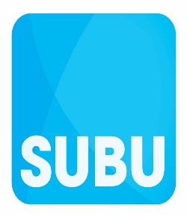

1. Foreword

2015/16 has seen an amazing range of activities with a diversity of great speakers such as Terry Waite CBE, Baroness Lawrence, and Debbie Simpson, the Chief Constable for Dorset. The many special events included the first Bournemouth Student Pride in February, and the extended programme for Eating Disorders Awareness Week 2016, which involved many external partners. This report presents a summary of all activities across BU which support the Vision and Values of BU2018, including culture, spirit and the institutional / global footprint.

Highlights of the year's achievements include the success of the Athena SWAN bronze institutional submission, which recognizes BU's approach to gender equality, and membership of the Equality Challenge Unit's Race Equality Charter. Our commitment to equality and diversity requires continual monitoring of relevant data, the outline of which is presented here, in order to detect trends, identify challenges and focus our activities.

This annual review reflects the shortening of the name of DDESG to the Equality & Diversity Steering Group, and presents the year's work in a shorter format. We have recruited new staff to the Steering Group, which now represents the protected characteristics under the Equality Act 2010, as well as the Faculties and Professional Services. The knowledge, skills and experience of the Steering Group members, both staff and students, mean that the work programme for the coming year will be tackled with expertise and enthusiasm.

Finally, we want to take this opportunity to thank Professor Stephen Jukes for his long and effective service as Chair of the Dignity, Diversity and Equality Steering Group (DDESG). We especially recognize his contribution to the high quality of the documentary projects completed over the last few years.

Professor Christine Maggs, Executive Dean of Science and Technology and Chair of the Equality and Diversity Steering Group

Jim Andrews, Chief Operating Officer and University’s Lead Director for Equality and Diversity
Reece Pope, SUBU Vice-President, Welfare 2015/16

2. Equality and diversity at BU: headlines for 2015/16

2.1 Policy

- BU became a member of the Equality Challenge Unit (ECU) race charter.
- A refreshed Equality and Diversity policy was published.
- A religion and belief policy was published.
- A new equality analysis procedure was developed with UCU and UNISON.
- 11 new Equality assessments were undertaken.
- BU subscribed to the ECU membership service.
- Head of Student Services is leading a University Leadership Team group on inclusive learning.

2.2 Students and staff

- The Good Lad programme delivered a development event for male and female sports captains.
- The programme of Forum Theatre work was continued, supporting the launch of the BU Dignity and Respect policy.
- Dignity and Wellbeing Advisers recruited last year attended a development event run by the Advisory, Conciliation and Arbitration Service (ACAS).
- The Students’ Union at Bournemouth University (SUBU) held its first Pride March during Lesbian, Gay, Bisexual, and Transgender (LGBT) history Month.
- BU students and alumni continued a programme of talks to fellow students, staff and the wider community about their own lived experience of mental health issues.
- Continued increase in the number of BU students agreeing to be filmed talking about the impact attending the Equality and Diversity events has had on their personal and professional development.
- SUBU Lansdowne Council ran its first Inclusive Feminism Campaign.
- The 2016 academic promotion/pay progression round is currently in progress and will be finished by the end of November 2016. An analysis of the results will be provided at the January meeting of the Equality and Diversity Steering Group.
- Work has progressed on the current equal pay action plan with a focus on the BME, disability and equality data actions.
- The 2016 professional and support pay progression round is currently in progress and will be finished by the end of November 2016. An analysis of the results will be provided at the January 2017 meeting of the Equality and Diversity Steering Group.
- SUBU elected its first black student president, for 2016/17.
- There were 11 reported hate incidents/crimes which affected BU staff and students on and off-campus. This increase can be attributed to international and national developments which have affected the region. Apart from these, there were only two incidents, which similar to previous years.
- In the reporting period, there were 13 academic appeals and two academic complaints that raised ‘equality and diversity’ elements at the Central Review Stage. An analysis of the cases shows the majority of the complaints/appeals were not upheld because the student was unable to substantiate their claim. Investigations found no equality or diversity issue that materially affected the vast majority of cases. All academic-related complaints are handled by Academic Services. In addition to the above there was one non-academic complaint concerning racism, which was handled by Student Services.
- There were three formal complaints from staff on equality related grounds.
- The Additional learning Support Service has responded to the changes in the Disabled Students Allowance. Office for Fair Access (OFFA) funding is being used to offset the drop in Disabled Students Allowance funding (DSA).

2.3 Community

- Organisations across Dorset came together to mark Black History Month and World Mental Health Day 2016. This involved individuals such as Terry Waite CBE, Baroness Lawrence, Norman Lamb MP, Prof Kevin Hylton and Dr Shirley Thompson speaking at BU.
- BU hosted the first Prejudice Free Dorset conference.
- The Very Reverend June Osborne, Dean of Salisbury, spoke at BU on the subject of “Equality and the Contortions of Faith, Tradition and the Demands of the Law.”
- Debbie Simpson, Chief Constable for Dorset spoke at BU to mark International Women’s Day 2016 as a collaborative project between Dorset Police and the Women’s Academic Network (WAN)
- Equality and diversity development sessions have been delivered to the Faculty of Health and Social Sciences students.
- An equality and diversity development session was delivered to the Practice Educator Learning partnership covering Bournemouth, Poole, Dorset and Wiltshire.
- “It’s Time to Talk about Mental Health Issues” paper accepted at the ECU national conference 2016, to discuss how mental health media work has developed over the last couple of years.
- BU in partnership with other local organisations supported the Dorset One World Festival, an event organised by Dorset Race Equality Council.
- BU hosted Bournemouth Soroptimist STEMM challenge event for the third time.
- The Shrievalty project for 2015/16, which was hosted by the High Sheriff for Dorset, had a mental health focus.
- BU supported Dorset Blind to run the “Try it Blind” campaign which raised £20,000 for the charity. Raising and Giving (RAG) have nominated Dorset Blind as their main charity for 2016/17.

3. Equality and diversity work programme for 2016/17 will include:

- Launch of the new equality analysis guidance throughout BU.
- To self-assess the current BU position against the Disability Confident principles and formally sign up to the scheme which replaces the “Two Ticks” scheme
- Complete the 2016/17 equal pay review and incorporate the recommendations into the equal pay action plan.
- Continue relevant actions identified in the unacceptable student behaviour (Lad Culture) action plan.
- Integrate inclusive learning principles throughout the BU student experience
- Review the current BU Gender Reassignment policy.
- Contribute to the BU Fair Access Agreement targets covering Black Minority Ethnic students and white working class boys.
- Deliver the promoting good relations development sessions to BU students and staff
- Develop a policy in relation to student parents.
- Start work on the Bournemouth University ECU, Race Equality charter work which will be launched during Black History Month 2016.
- Continue to support and progress the BU, faculty and departmental Athena SWAN work
- Provide support to the equality and diversity aspects of the BU 2021 Research Excellence Framework submission.
- Launch the BU Respect campaign at key stages throughout the academic year.
- Mark the following national equality and diversity events: Black History Month; World Mental Health Day; Hate Crime Awareness week; Disability History Month; Carers Rights Day; International Day for the Elimination of Violence Against Women; Women’s Aid 16 Days of Action Campaign; LGBT History Month; Eating Disorder Week; University Mental Health Day; International Women’s Day; International Day Against Homophobia and Transphobia; Mental Health Week.
- Develop the business case for BU becoming a Stonewall Diversity Champion (Sexual Orientation/Transgender).

4. Impact

We’ve selected some examples of the work and achievements of last year. The links at the end of each example provide readers with the opportunity to read a Storify or review individual videos.

Impact 1: Dignity and Respect

Goal: | Raise awareness of the negative impact of bullying, harassment and victimisation on BU students and staff
Activity: | Progress a programme of dignity and respect work at BU that promotes a zero tolerance approach to any forms of bullying, harassment and victimisation on or off campus.
Aligned to BU/  SUBU Strategic plans: | BU strategic plan  - P3C. Maintain and enhance a working environment that enables and supports staff well-being.  - C5A. Ensure exposure to diversity through, and integration in, other cultures as part of  Fusion and non-academic activities.  - C5B. Create an increasingly diverse staff and student body.  SUBU strategic plan  - SUBU understood and recognised as well as accessible and approachable by all students.  - SUBU helping people to realise their potential.
Selected outputs: | - Good Lad programme delivered during April 2016  - 38 students attended the Good Lad programme (55% male; 45% female).  - Respect at BU video completed which will be launched in 2016/17.  - Unacceptable behaviour action plan (Lad Culture) developed as a joint piece of work between BU and SUBU.  - Forum Theatre programme delivered to 116 BU staff.  - Respect at BU posters finalised.  - Dignity and Wellbeing Adviser development delivered via ACAS.
Selected examples of changes of behaviour/  impact: | - 60% of attendees of the Good Lad development event felt the sessions had changed their behaviour. “It's made me think about situations which I may have been involved in which could have had a better/worse outcome.” (Participant feedback on the Good Lad programme).  - 84% of attendees who attended the Forum sessions felt more confident in encouraging team members to share concerns about unacceptable behaviour.  “This was an excellent session to unpick some of the thornier issues around e.g. office banter & perspectives on bullying. Would recommend & would like to see more training in this style.” (Participant feedback on the Forum Theatre programme).  “I was working with Senior Leaders in IT today and they commented on how their teams really enjoyed the Forum Theatre and it was mentioned frequently in conversation thereafter!” (Facilitator feedback on the Forum Theatre workshops)
Further information | - Evaluation of the Good Lad programme 2015/16  - Evaluation of Forum Theatre 2015/16

Impact 2: Gender Equality

Goal: | To raise awareness of staff, students and the wider community that gender equality has the potential to provide success for all
Activity: | Implementation and development of the Athena SWAN institutional action plan and supporting the Faculty of Health and Social Sciences, Departments of Psychology, Life & Environmental Sciences and Computer Science & Informatics who are making departmental submissions.
Aligned to BU/SUBU Strategic plan: | BU strategic plan  - C5B. Create an increasingly diverse staff and student body.  - P3D. Realise the benefits of a diverse and engaged workforce.  SUBU strategic plan  - SUBU understood and recognised as well as accessible and approachable by all students.  - SUBU helping people to realise their potential.
Selected outputs: | - A parental/carers leave survey as part of the institutional Athena SWAN work has been undertaken.  - A programme of events to mark International Women’s Day 2016 was delivered in partnership with the Faculty of Health and Social Sciences, Department of Archaeology, Anthropology & Forensic Science, Women’s Academic Network and Dorset Police.  - Faculty of Health and Social Sciences undertook a survey of all its staff.  - Presentation on Athena SWAN has been made to the Executive for the Faculty of Management.  - Dedicated staff time has been allocated to support the development of the Life and Environmental Sciences Athena SWAN submission.  - 80% of academic staff within the Department of Life and Environmental Sciences have attended unconscious bias training (some of these sessions were available to all staff within the Faculty of Science and Technology).  - Unconscious bias development provided to the Faculty of Health and Social Sciences Staff.
Selected examples of changes of behaviour/  impact | - The Department of Media Production has agreed to develop a departmental Athena SWAN submission.  - The Department of Psychology Athena SWAN self-assessment team will also consider other equality and diversity issues such as race and disability.  - “Makes me more motivated to work harder and expand my opportunities.” (Participant feedback on International Women’s Day 2016 talks).  - 90% of attendees of one of the talks for International Women’s Day 2016 felt that they have learnt or experienced something that will change the way they work, live or think.  - “She did not disappoint - she was incredibly positive about her work and clearly inspired a room full of professionals and students alike. As a journalist, she opened my eyes to the media portrayal of the AIDS virus.” (Participant feedback on International Women’s Day 2016 talks).  - Faculty of Science and Technology have introduced a six month research-only period for staff returning to work after maternity leave.
Further information | https://storify.com/EqualityatBU/international-women-s-day-2016

Impact 3: Mental Health

Goal: | To support key national equality and diversity events at BU which encourage more open discussion about mental health with students, staff and the wider community
Activity: | Continue to promote a positive approach to wellbeing, including mental health at BU/SUBU for all its staff, students and the wider community by delivering development opportunities in support of the Time to Change Organisational Pledge and promoting the Mindful Employer.
Aligned to BU/SUBU Strategic plan | BU strategic plan  - C5A. Ensure exposure to diversity through, and integration in, other cultures as part of Fusion and non-academic activities.  - P3D. Realise the benefits of a diverse and engaged workforce.  - P3C. Maintain and enhance a working environment that enables and supports staff well-being  SUBU strategic plan  - SUBU as a major collective force for all students.  - SUBU understood and recognised as well as accessible and approachable by all students  - SUBU creating friendships.  - SUBU helping people to realise their potential.
Selected outputs: | - Programme of events for World Mental Health Day 2015 and Eating Disorders Week 2016 in partnership with 9 external partners.  - Submission made to Mind Media Awards 2016  - Mindful Employer submission made (feedback noted the excellent examples of connecting with the wider Community).  - Radio interviews on Radio Solent and Breakfast Dorset.  - Level H Psychology students taking the Eating, Weight and Behaviour Change unit were expected to attend two talks during Eating Disorders Week 2016.  - £123.50 was raised for BEAT as part of the Normally Abnormal gig for Eating Disorders Awareness Week 2016.
Selected examples of changes of behaviour/  impact | - Increase in the number of BU students/alumni talking about their own lived experience of mental health issues.  - “On the night I had a partner of someone with eating disorders come up and thank me and ask for help. I also had 3 more audience members on the night who said they had personal experience of eating disorders and said how helpful, cathartic and funny the show had been.” (Comedian feedback, on ‘Normally Abnormal’ gig for Eating Disorder Awareness Week 2016).  - BU students sharing their experiences on videos about how attending the events has helped their studies.  - Feedback from the Occupational Therapy programme lead has seen a positive impact on students who attended the mental health and eating disorder week programme of events over the last three years, shown through their Continuing Professional Development Logs.  - Local School students and members of the public approached a speaker for World Mental Health Day 2016 to seek advice and support.
Further information | - https://storify.com/EqualityatBU/mental-health-awar  - https://storify.com/EqualityatBU/awareness-recovery-and-hope-in-eating-disorders-th  - https://storify.com/EqualityatBU/eating-disorders-awareness-week

Impact 4: Students’ Union (SUBU) Equality and Diversity events

Goal: | To continue to develop a programme of activities to raise student awareness of equality and diversity issues.
Activity: | SUBU to initiate, or support BU students to deliver, a programme of equality and diversity events on and off-campus.
SUBU Strategic plan: | The SUBU vision is that: “By 2016, SUBU will have a positive impact on every BU student’s.  journey.” It plans to achieve this though 5 key strategic themes:  - SUBU as a major collective force for all students.  - SUBU understood and recognised as well as accessible and approachable by all students.  - SUBU creating friendships.  - SUBU helping people to realise their potential.  - SUBU will be ethical and environmental in its activities.
Selected outputs: | Delivered a programme of events to mark:  - Black History Month.  - One World Day.  - LGBT History Month.  - Diwali.  - Trans Day of Remembrance.  In addition SUBU worked with students to deliver the following events:  - One World Day.  - Mature Students Coffee Socials.  - Feminist Society Talk with Professor Emma Rees from University of Chester.  - Inclusive Feminism Campaign.  - Refugee Awareness Campaign.  Other activity  - RAG raised £4,566.27 in one weekend for Diversity Abilities by Leggit (charity hitch hike)  - 270 students attended a world record attempt to simultaneously wrap the largest amount of Christmas presents for local children with Barnardo’s.  - SUBU has continued to support local charities such as the Alzheimer’s Society through providing student volunteers
Selected examples of changes of behaviour/  impact | - Participants gave the One World event an excellent rating  - The success of Bournemouth Student Pride can be undoubtedly be measured by the student overheard in the student centre saying “'I came out today, film me! I'm finally proud of who I am."  - A SUBU ‘STAR’ Network was created as a result of the Refugee Awareness Campaign to keep raising awareness and advocating for Asylum and Refugee rights on-campus.
Further information | Bournemouth Student Pride video

5. Equality data

This part of the annual report provides an overview of student and staff equality data including student and staff headcount as well as attainment. Three-year trends are shown for some student and staff data from the Higher Educational Statistical Agency (HESA). This report makes comparisons for BU data from HESA with the sector (all HEIs) and with south-coast HEIs. BU student data are provided by BU Student Administration and drawn from Academic Standards and on-line registration data which cannot be compared with national statistics. A Faculty and Professional Service equality and diversity profile will be provided at the November Equality and Diversity Steering Group meeting for further discussion and consideration. Written percentages have been rounded (to the nearest 1%) and may not total 100%.

5.1 HESA student equality data for all HEIs, south-coast HEIs and BU: three year trends

Student age profile (% under 21) at BU compared with all HEIs/South-Coast HEIs

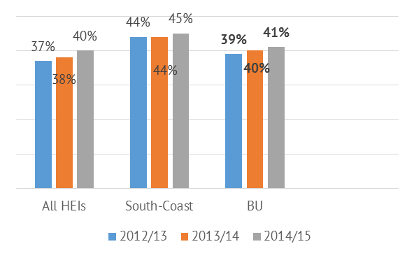
South-coast HEIs have a much younger student population than the sector (all HEIs), which includes many big-city universities. The BU student population is more similar to the sector than to the south-coast HEIs but it is getting younger each year and hence moving towards the age profile of the south-coast HEIs.

Student disability at BU compared with all HEIs/South Coast HEIs
The percentage of BU students declaring a disability is higher than for all HEIs and south-coast HEIs; however it is stable in BU and rising year on year across the sector, so next year we can predict similar percentages for all university groupings
. 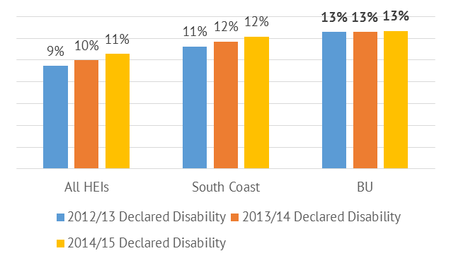

Student gender at BU compared with all HEIs/South-Coast HEIs
The percentage of female students in each of the three university categories is generally stable, with BU being very similar to the sector (all HEIs) and with a higher % female than for south-coast HEIs. Given the general stability in all university groupings, the rise of over 1% for females for BU in 2014/15 may be significant.

BME student profile at BU compared with all HEIs/South-Coast HEIs (home/international)

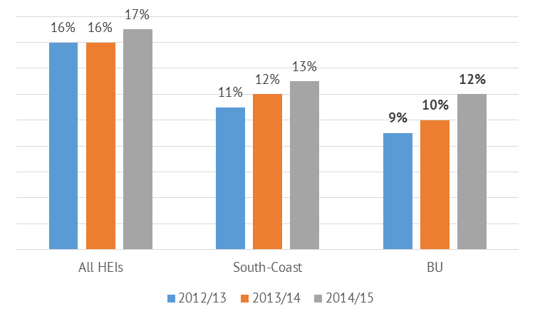
BU and other south-coast HEIs have a much lower proportion of BME students than the sector (all HEIs), which includes many big-city universities. However, the proportion of BME students is increasing across all three groupings, fastest at BU where it has grown by about one-third in three years.

Non-EU students at BU compared with all HEIs/South-Coast HEIs

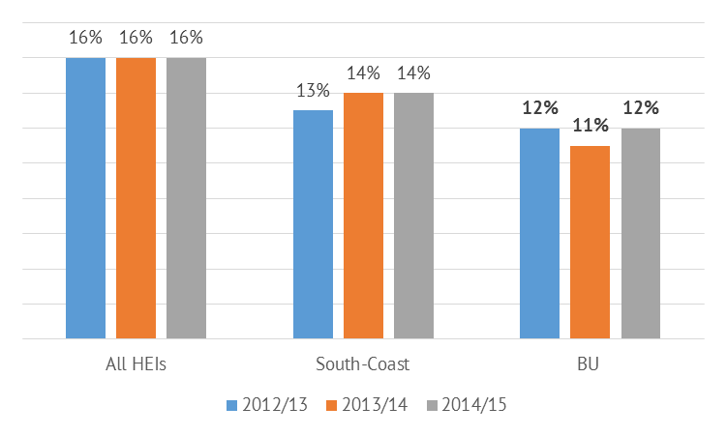
The percentage of non-EU students in each of the three university categories is generally stable. It is lower at BU than the south-coast HEIs average, which is lower than the sector (all HEIs).

BME student attainment at BU compared with all HEIs/South-Coast HEIs

Comparison of BME student attainment (First Class/2.1 degrees) for one year (2013/14) at BU versus the south-coast HEIs and the sector average shows that BME student attainment is actually highest at BU. However, because White attainment is relatively high at BU, the BME attainment gap is greatest at BU.
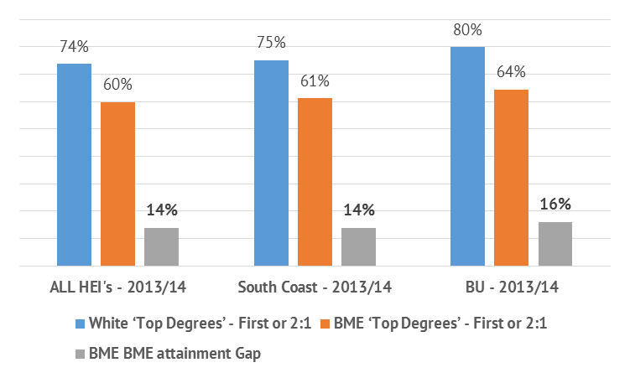

Disability student attainment at BU compared with all HEIs/South-Coast HEIs
Comparison of Disabled student attainment (First Class/2.1 degrees) for one year (2013/14) at BU versus the south-coast HEIs and the sector average shows that Disabled student attainment is actually highest at BU. However, because Non-disabled attainment is relatively high at BU, the Disabled attainment gap is slightly higher at BU than at the south-coast HEIs, and markedly greater than for all HEIs.

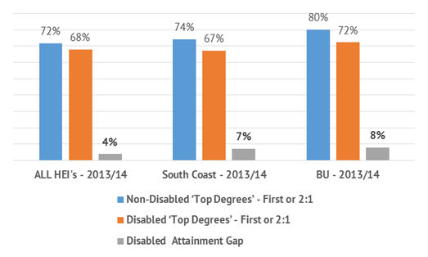

Student attainment by gender at BU compared with all HEIs/South-Coast HEIs
Comparison of student attainment (First Class/2.1 degrees) by gender for one year (2013/14) at BU versus the south-coast HEIs and the sector average shows that male student attainment is actually highest at BU. However, because female attainment is relatively high at BU, the gender attainment gap is slightly higher at BU than at the south-coast HEIs, and markedly greater than for all HEIs.
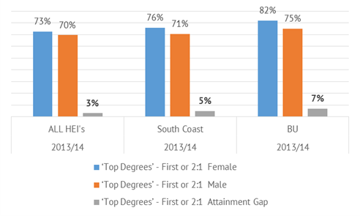

5.2 HESA staff equality data

Staff under 45, by age group, at BU compared with all HEIs/South-Coast HEIs

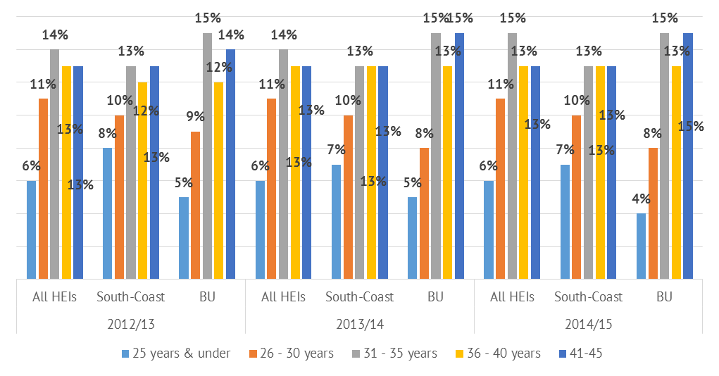Staff aged 46 and over, by age group, at BU compared with all HEIs/South-Coast HEIs
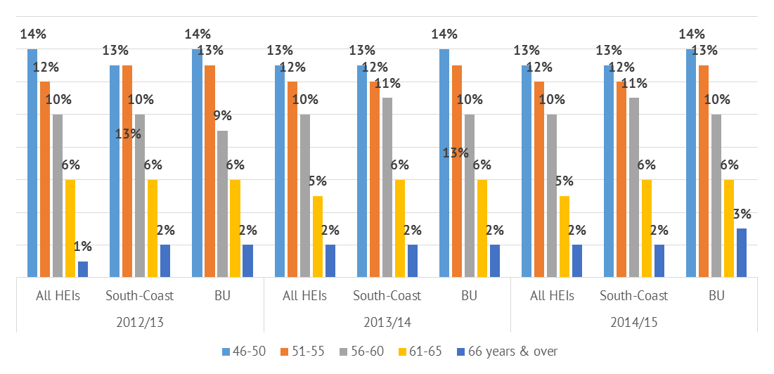

Comparison of staff age profiles for three years at BU versus the south-coast HEIs and the sector average shows that BU has a lower proportion of very young staff (<25) compared to the sector and a slightly higher, and rising, proportion of older staff (65+).

BU disability staff profile compared against all HEIs/South-Coast

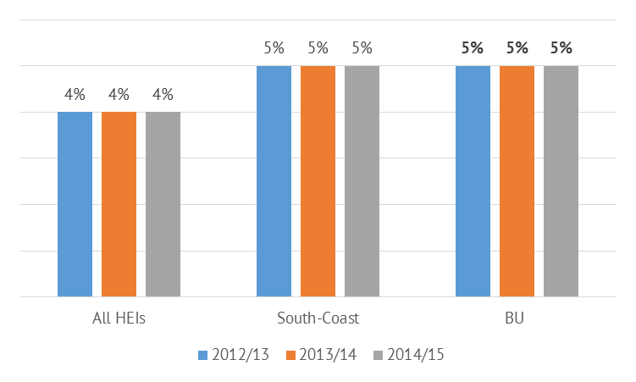
A similar proportion of staff have a declared disability in each of the three university groupings, increasing very slightly year on year, with slightly higher proportions in south-coast HEIs and BU than across the sector.

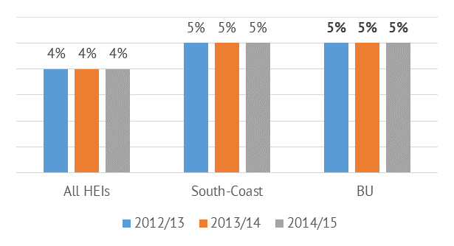
A similar proportion of staff have a declared disability in each of the three university groupings, increasing very slightly year on year, with slightly higher proportions in south-coast HEIs and BU than across the sector.

BU BME staff profile compared against all HEIs/South-Coast
The proportion of BME staff is increasing slightly year on year in each of the three university groupings, with lower proportions in south-coast HEIs and BU than across the sector.
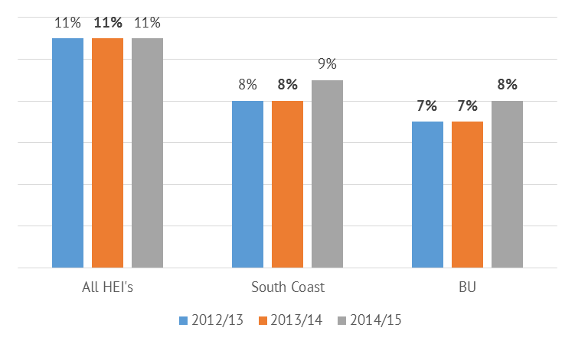

BU staff nationality (non-EU) profile compared against all HEIs/South-Coast
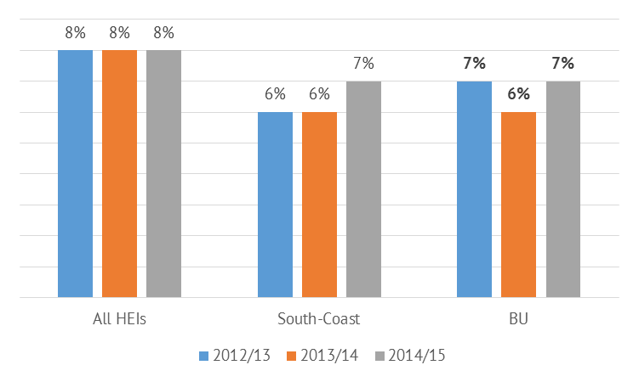
The percentage of non-EU staff in each of the three university categories is generally stable. Both BU and the south-coast HEIs average are below the sector average (all HEIs).

Staff gender at BU compared with all HEIs/South-Coast HEIs

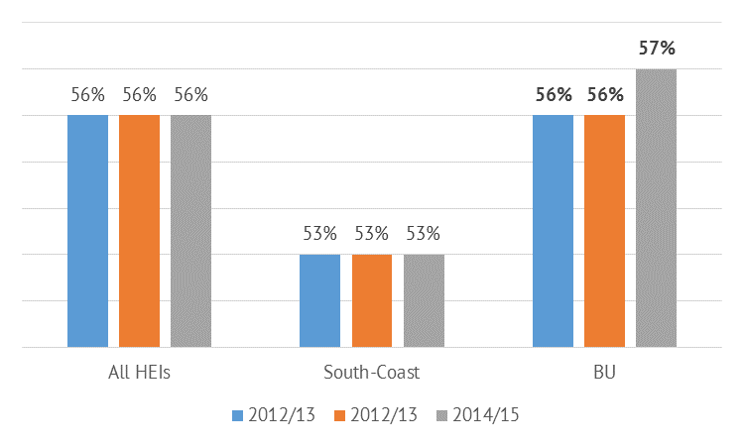

When compared to the sector and the South Coast, BU now has a higher proportion of female staff.

5.3 Bournemouth student university equality data 2015/16

BU student age profile
The majority of the students (65%) studying a BU programme are under the age of 21.
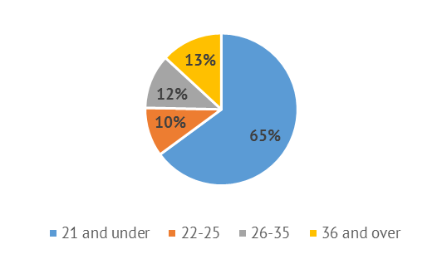

BU disability student profile

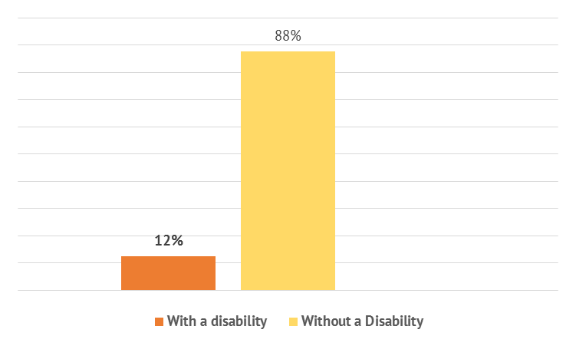
The 12% declared disability value is similar but not identical to that obtained by HESA in the previous year (13%).

BU student ethnicity (home/international)

Asian and Black students represent the largest proportion of the 18% BME students studying a BU programme.
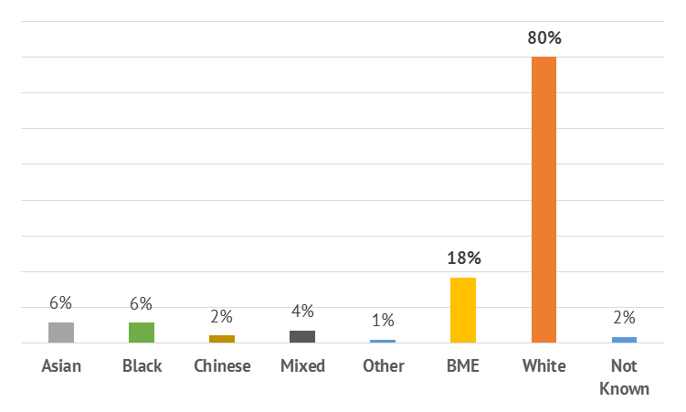

BU student gender
The University has a higher proportion of female students studying a BU programme.

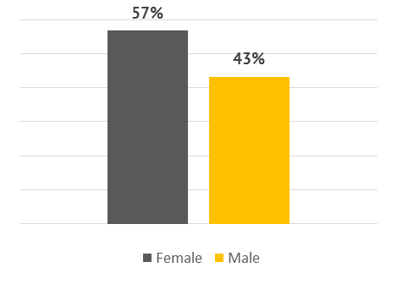

BU student gender reassignment
Given the 46% response rate, these data are of limited value. A total of 19 students have disclosed that their gender has changed since birth.
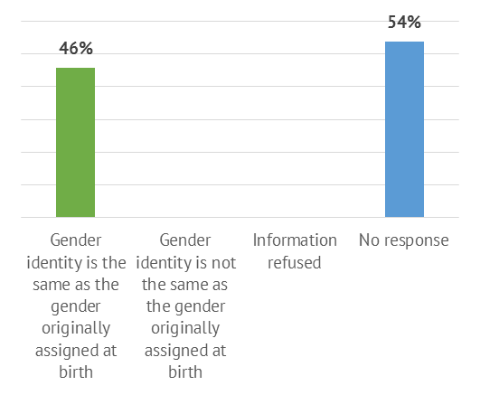

Religion and belief of BU students

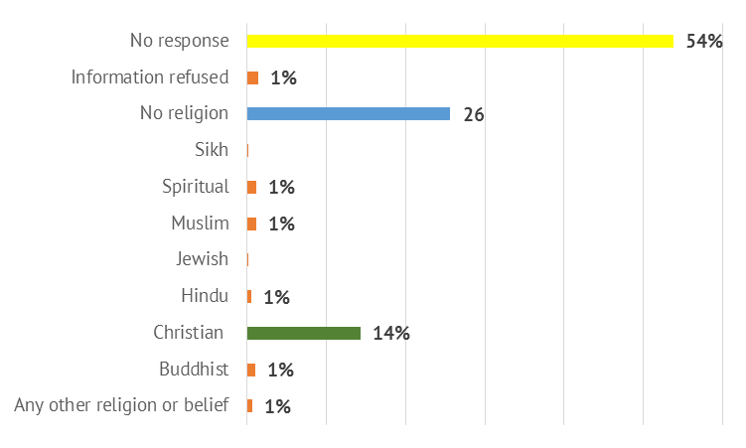
Given the 45% response rate, these data are of limited value.
Sexual orientation of BU students

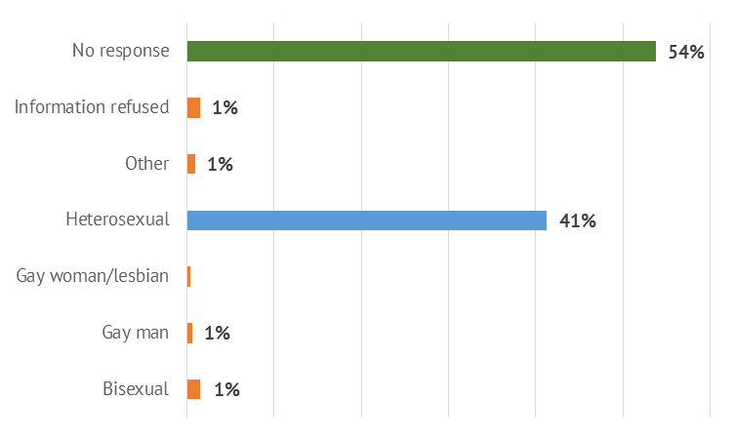
Given the 45% response rate, these data are of limited value.

Attainment of BME students at BU
There is a large discrepancy between these data and HESA's (e.g. for 2013/14 HESA has an attainment gap of 16%); also note that BME students at BU have better attainment levels than BME students across the sector.
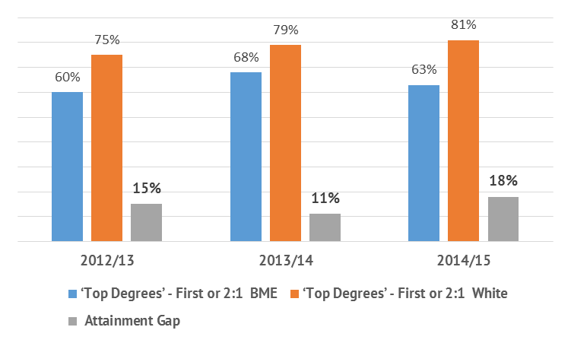

Attainment of students by gender at BU

There is a large discrepancy between these data and HESA's (e.g. for 2013/14 HESA has an attainment gap of 7%); also note that male students at BU have better attainment levels than male students across the sector.

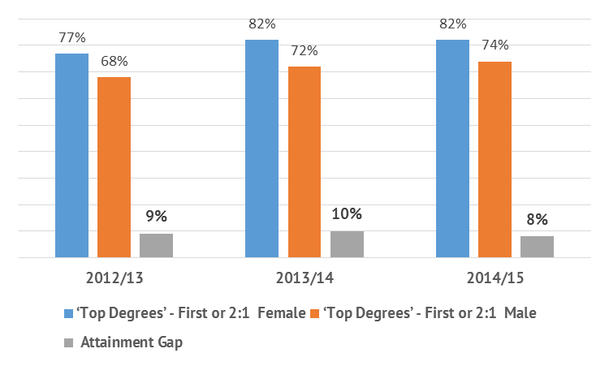

Attainment of students with a declared disability at BU
There is a large discrepancy between these data and HESA's (e.g. for 2013/14 HESA has an attainment gap of 7%); also note that Disabled students at BU have better attainment levels than Disabled students across the sector.

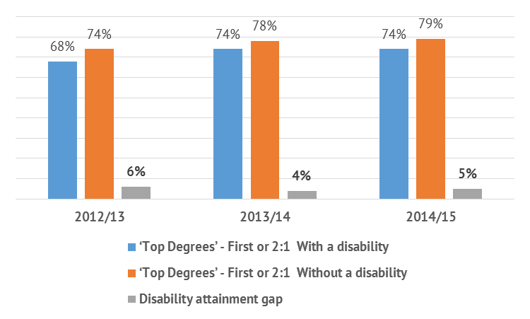

5.4 Bournemouth staff university equality data 2015/16

BU staff age profile

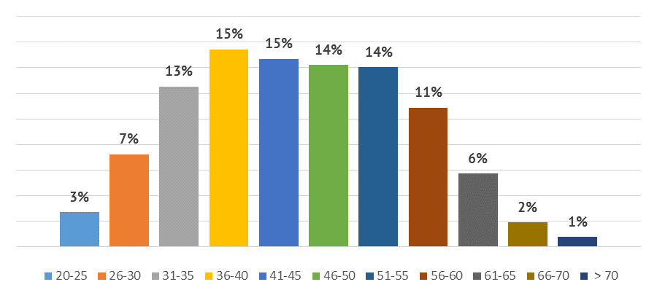

The majority of staff are aged 36-60, but some older staff include ages >70.

BU disability staff profile

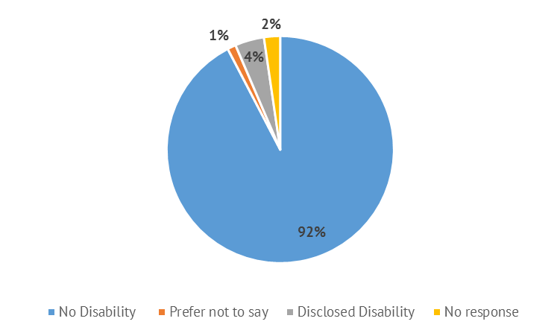
The great majority of staff indicated no disability; 4% disclosed a disability. This is lower than the HESA data, which indicated 5% staff with a declared disability.

BU staff ethnicity (home/international)

The majority of staff are white. The 9% BME staff shown here is slightly higher than the HESA data (8%). The breakdown across groupings indicates that the largest defined group is Chinese.

BU staff gender profile

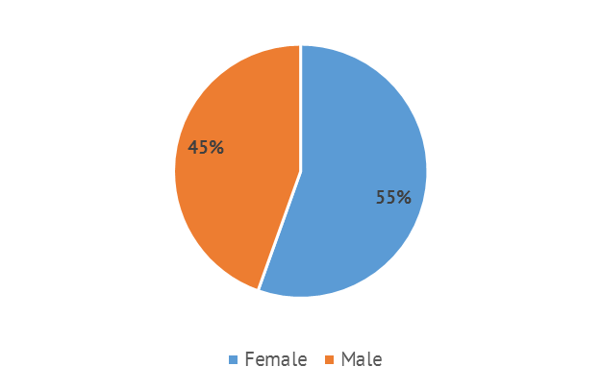
The gender balance of all staff shows a female bias in the data.

BU staff gender reassignment

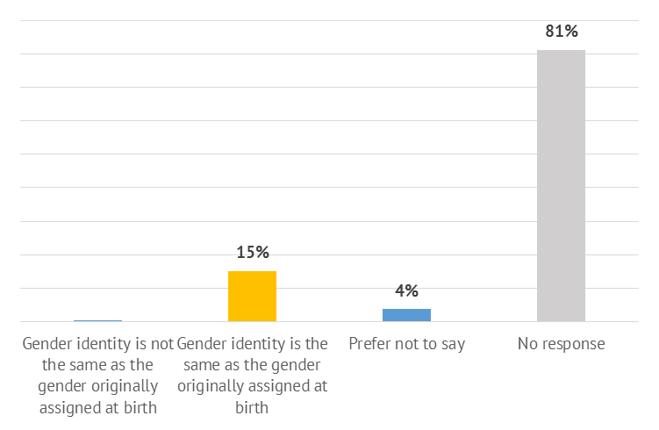

BU staff sexual orientation

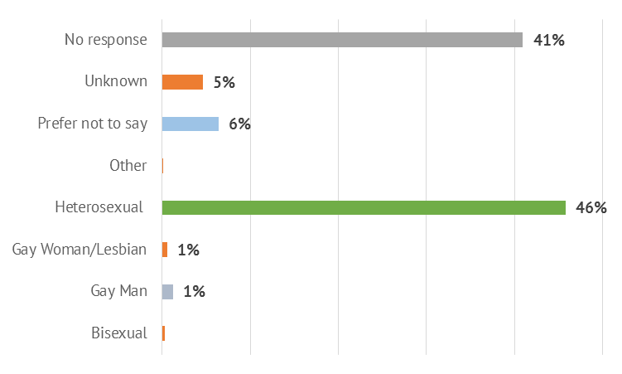

The majority of staff did not respond to these questions; of those who did the great majority had the same gender identity as at birth, and were heterosexual (< 3% of the population were gay, lesbian or bisexual).

BU staff who are parents

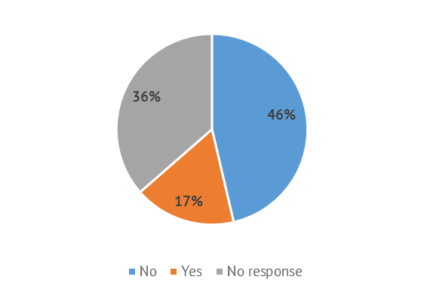
The majority of staff who responded to this question reported that they were not parents but these data may not be accurate.

6. Endnotes

- This annual report covers the period 31 July 2015-1 August 2016.
- HESA student and staff data have been provided by PRIME.
- The HESA attainment data is taken from the DLHE (Destinations of Leavers of Higher Education) 2013/14 leaver data in HEIDI (Higher Education Information Database for Institutions), which is the latest available dataset. Student attainment data are only based on those students studying at first degree level (not masters, PGT, PGR etc.), as these are the only attainment data within HEIDI.
- Student data have been provided by Student Administration.
- Staff data have been provided by Human Resources.

